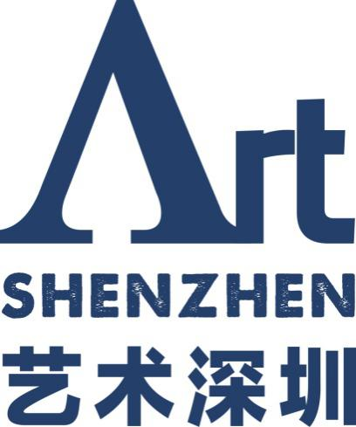
Exhibition Application For Art Derivatives
September 12-15,2019
Hall 6, Shenzhen Convention & Exhibition Center

Art Derivatives Space — Application is available to contemporary art derivatives boutiques with independent brands.

CONTENT

Dates

Information

Booth

Application &Instructions

Dates

Application Deadline: June 20, 2019
(Commenced from May 10, 2019)
Exhibition Notice: June 30, 2019
Exhibition Fees Payment: July 15, 2019
List Announcement: July 20, 2019
Official Weibo&Wechat Promotion: August 10, 2019
Exhibition Move-in:
17:00 – 22:00 (Wednesday) September 11, 2019
09:30 – 14:00 (Thursday) September 12, 2019
VIP Preview: 14:30 – 18:00 (Thursday) September 12, 2019
Opening Ceremony: 18:00 – 21:30 (Thursday) September 12, 2019
Public Days:
10:00 – 19:30 ( Friday & Saturday) September 13 – 14, 2019
10:00 – 17:00 (Sunday) September 15, 2019
Exhibition Move-out: 17:00 – 21:00 (Sunday) September 15, 2019

Information
Name (Chinese):
Name (All English Capital Letters):
Address:
Country (City): Postal Code:
E-mail: Tel:
Operation Date:
Opening Hours:
Branch Address If Available:
Owner (Director): (Mr. / Mrs. / Ms.)
Email: Mob:
Contact Person: (Mr. / Mrs. / Ms.)
Email: Mob:
Registered Company Name:
Billing Address (Please Note If Different From Gallery Address):

Contents:

Exhibition Plan for Art Shenzhen 2019:

- Please insert a page(s) in case of limited space above.

Booth

Exhibition booth area of Art Derivatives Space is 15 m², RMB 15,000.

Exhibition Booth Fees Cover:
- Walls (default color white)
- Lightings &circuits (per 3 m²)
- Exhibitor badges & VIP Invitation Letter (3 Exhibitor Badges, 3 Staff Badges, 2 VIP Cards)
The Organizing Committee of Art Shenzhen 2019 (hereinafter referred to as the Organizing Committee) may not guarantee the requirements for exhibition booth size and location. Adjustments of actual exhibition booth size and location may occur according to space limitations and overall application requirements. The Organizing Committee reserves the rights of final decision on exhibition booth arrangement and exhibition planning.
This is an exhibition intent application form (informal exhibition contract)
Approved Application | The Organizing Committee with full powers of strict control on the number and quality of exhibitors reserves the rights of final selection and signs formal exhibition contracts with selected galleries in July, 2019.

Application Documents & Instructions

Please send a PDF (less than 12 MB including completed Exhibition Application Form and other attachments) to vip@artshenzhen.com
Exhibition Application List Includes:
■ Completed and signed Exhibition Application Form
■ Introduction, exhibition history in recent years
■ Exhibiton contents
■Photos and description of exhibits (5 at most with names, sizes, materials, dates);Submission of complete electronic documents or website links is required in case of declaration of new media artworks.
■Exhibition booth design, texts
■Personnel information (ID Card copy, phone number, Email) required for exhibitor badges and VIP invitation letters (3 Exhibitor Badges, 3 Staff Badges, 2 VIP Cards)
Substandard application is NOT approvable and acceptable by the Organizing Committee. Applicants are liable for the submission of required documents.

■Submission of Application Documents
The Exhibition Application Form is required to be completed, signed, and emailed to the Organizing Committee. Please keep back-ups as all submitted documents are non-returnable. Incomplete documents may hinder or fail application and any unnecessary documents are not acceptable.
■Confirmation of Application Documents
Confirmation comes via email after receipt of application by the Organizing Committee. Please contact us to complete application procedures in case of undelivered confirmation letter after 10 working days as of application submission.
■Application Approval
The Organizing Committee reserves the rights of assessment of application documents from exhibitors and replacement of exhibits and artists. Assessment results come via email and then exhibition contract are concluded with approved galleries.
■Payment
Approved exhibitors shall make all payments on the scheduled date for rights, interests and qualification after the conclusion of formal exhibition contract. The Organizing Committeereserves the rights of cancellation of exhibition qualification and replacement in case of payment failure within the scheduled date. Extra tax payment is required in case of Value-Added Tax Invoice and Value-Added Tax Special Invoice.

We confirm the preparation of all required application documents and read and agree to abide by the relevant regulations and provisions of Art Shenzhen 2019.

Name: Seal:

Signature of Person in Charge: Signature Date:

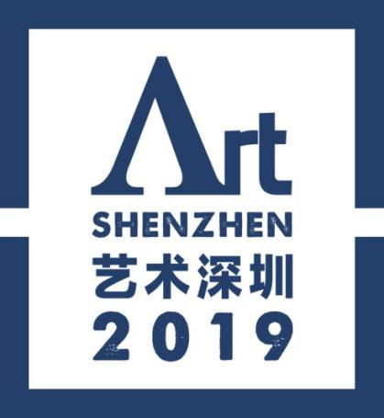

Host: Organizing Committee Office of China (Shenzhen) International Cultural Industries Fair, Shenzhen Press Group

Organizers: Shenzhen International Cultural Industry Fair Co., Ltd., Organizing Committee Office of Art Shenzhen, Shenzhen ICIF Auction Co., Ltd.

Address: 10/F, Olympic Building, Economic Daily Road, Futian District, Shenzhen, P.R.C.

Postal Code: 518034 Fax: 86-755-83521000

Tel: 86-755-83522737, 83521084

END

